**Non-public appendix belonging to Application form Part A  
  
Assessment of clinical research involving gene therapeutics in the Netherlands**

**-**

***Consent form***

**November 2018**

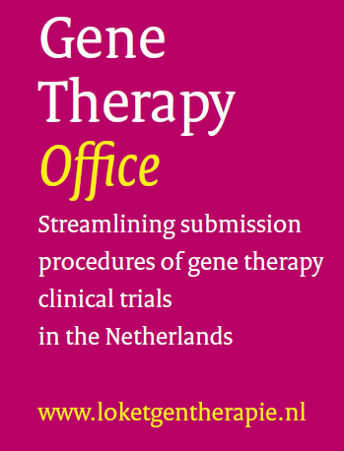

# Consent form (non-public part)

On behalf of the legal entity a person must sign who is registered as an authorized signatory in the Dutch Business Register (NHR). A person may also be mandated to sign on behalf of public legal entities. This mandate showing the authority to sign must be submitted together with the application.

The undersigned:

Hereby gives his/her consent to the gene therapy office to send on the application forms and the accompanying file to the relevant assessment authorities.

Gives his/her consent to the assessment authorities to use the fully completed file in making its assessment.

Gives his/her consent to the assessment authorities to inform each other and the gene therapy office about the status of the submitted application.

Signed (with pen sign on printed copy):

Name:

Date:

**Submission via ‘*berichtenbox*’ (Message Box)**

Forms that are submitted via the ‘*berichtenbox’*  do not have to be signed by a person who is registered as an authorized signatory in the Dutch Business Register (NHR). The ‘*eHerkenning*’ of the ‘*berichtenbox’* procedure is sufficient.

□ Tick this box if this document is submitted via the ‘*berichtenbox’*.